

Application Note

BRT_AN_073

ESD Exported Project Porting Guide for STM32L4 Discovery Board

**Version 1.1**

**Issue Date: 2023-08-16**

This application note is intended as a guide for porting an EVE Screen Designer (ESD) exported project to a non-FT9xx based MCU platform. Users are expected to have knowledge of ESD as well as BT81x and STM32L4 MCU.

Table of Contents

1 Introduction 3

Overview 4

Scope 4

2 ESD Exported Project - Introduction 5

3 Porting principles 7

Hardware 7

Software 7

4 Example 8

Hardware Connection 9

4.1.1 Power and Ground Connection 9

4.1.2 Signal lines Connection 10

Software Setup 10

4.1.3 Toolchain and Utility 10

Project porting procedure 11

4.1.4 Create project on ESD and generate source code for eclipse IDE 12

4.1.5 Generate project for STM32L4 Discovery board 15

4.1.6 Port ESD generated source code to STM32L4 Discovery’s project 20

4.1.7 Build and run on STM32L4 Discovery board 24

4.1.8 Storage Media Configuration and Access 26

4.1.9 APIs Re-Implementation 27

Appendix A– References 30

Document References 30

Acronyms and Abbreviations 30

Appendix B – List of Tables & Figures 31

List of Figures 31

List of Tables 32

Appendix C– Revision History 33

Appendix D – Sample source code 34

# Introduction

This application note is intended as a guide for porting an **E**VE **S**creen **D**esigner (**ESD**) exported project to an ARM Cortex-M4 based MCU platform, i.e., STM32L476 Discovery board. An example project “EvChargePoint” exported from **ESD** and the **STM32CubeIDE** are used to showcase the porting procedure. Readers are expected to have the knowledge of ESD as well as **STM32CubeIDE**.

This application note provides a step-by-step example using EVE module VM816C with a BT816 and LCD 800x480 resistive touch, below is the list of tools used:

|  |  |
| --- | --- |
| Hardware | Information |
| VA800A-SPI | brtchip.com/wp-content/uploads/Support/Documentation/Datasheets/ICs/EVE/DS_VA800A-SPI_MPSSE_Module.pdf |
| VM816C | brtchip.com/wp-content/uploads/sites/3/2021/07/DS_VM816C.pdf |
| 5.0 inch Premium Resistive TFT Display | Newheaven display NHD-5.0-800480TF-ATXL#-T  https://newhavendisplay.com/5-0-inch-premium-resistive-tft-display/ |
| 32L476GDISCOVERY | https://www.st.com/en/evaluation-tools/32l476gdiscovery.html |

Table : Hardware list

|  |  |  |  |
| --- | --- | --- | --- |
| Tool | Version | License | Information |
| **E**VE **S**creen **D**esigner (**ESD**) | 4.16 | Free | https://brtchip.com/esd/ |
| EVE Asset Builder | 2.6.1 | Free | https://brtchip.com/eab |
| STM32CubeIDE | 1.13.0 | Free | https://www.st.com/en/development-tools/stm32cubeide.html |
| STM32CubeMX | 6.9.1 | Free | https://www.st.com/en/development-tools/stm32cubemx.html |

Table : Software list

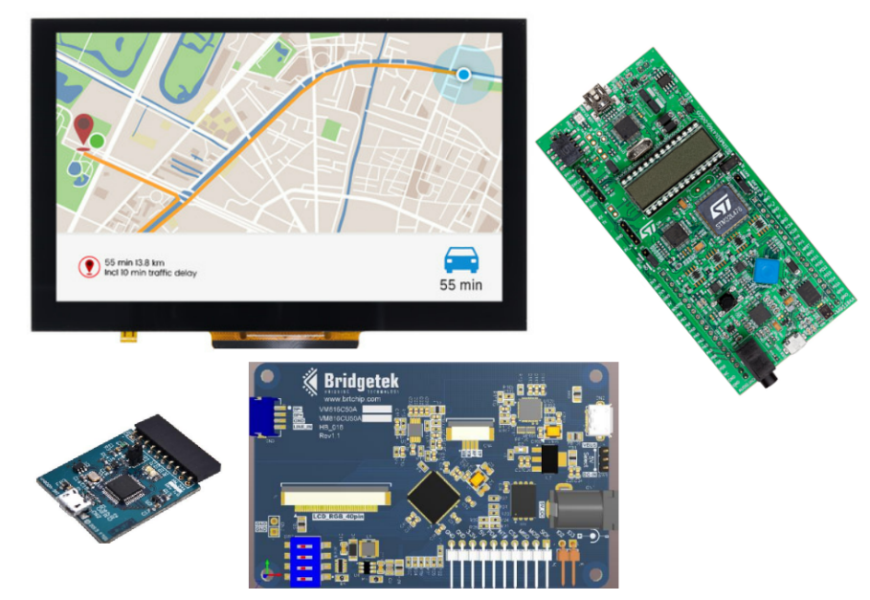

Figure Hardware list

## Overview

This guide covers the following topics:

* ESD exported project introduction.
* Principles of porting.
* Example.

## Scope

This document covers hardware changes and software modification as well as some debugging tips while porting the exported project. It also provides some basic principles to successfully port a project.

# ESD Exported Project - Introduction

ESD 4.16 enables users to design an EVE based GUI application with minimum effort. Upon completing the design and successfully simulating it on a PC, users can choose to export the currently opened project by selecting **“File → Export Project”**, as shown figure below:

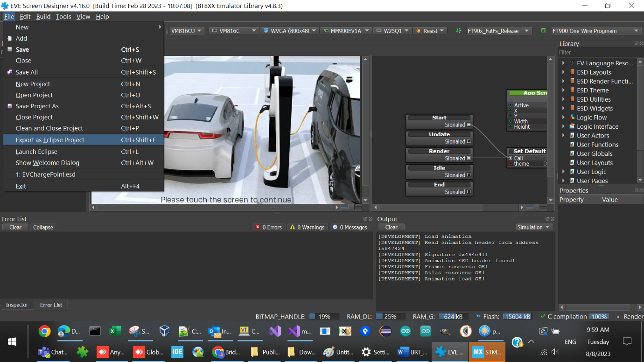

Figure Export EvChargePoint project in ESD 4.16

“EvChargePoint**Error! Reference source not found.**” project is located at “$(ESD4.16Installation Path)\Examples\Advanced” folder and user can open it in ESD4.16directly.

The “$(ESD4.16Installation Path)” is set to “C:\Users\Public\Documents\EVE Screen Designer” by default.

Users are prompted to select a new folder as the destination folder to export. Once exporting is done, the destination folder shall be as below:

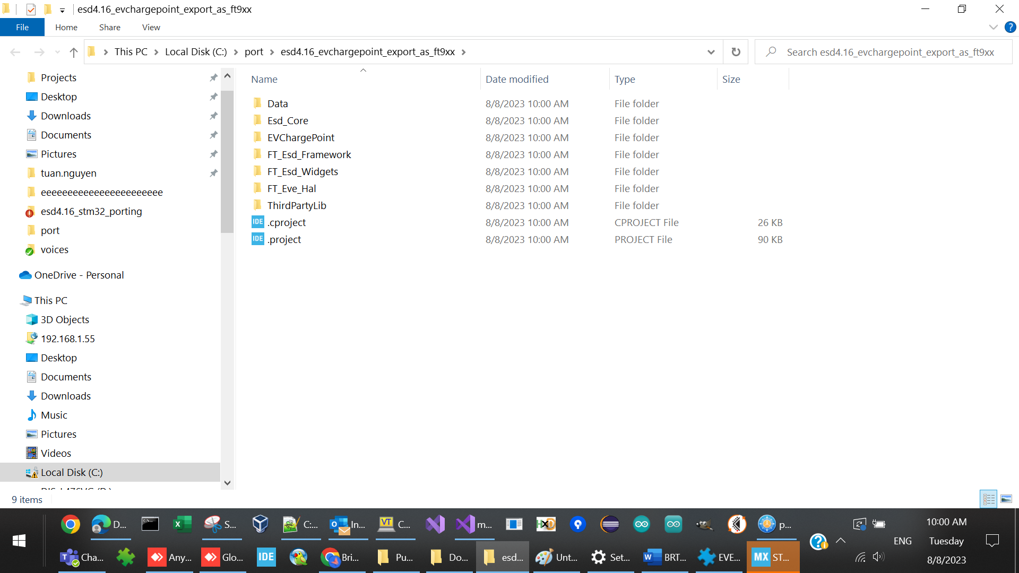

Figure : Folder Structure of Error! Reference source not found. Project

| Folder / file Name | Description | Remarks |
| --- | --- | --- |
| Data | Contains the converted bitmap assets | Do not need to change. |
| ESD_Core | Contains application framework source code | Reusable and common module |
| **Error! Reference source not found.** | The project file contains the screen logic and users design | The folder name shall be same as project name |
| FT_Esd_Framework | Contains application framework source code | Reusable and common module |
| FT_Esd_Widgets | Contains the widgets-related source code | Reusable and common module |
| FT_Eve_Hal | Contains hardware abstraction layer | The major folder to be changed |
| ThirdPartyLib | Contains the third part library | Currently only FatFs Library source code inside |
| .cproject | Eclipse CDT project file | Build configurations, tool chains, individual tools etc. |
| .project | Eclipse CDT project file | Build specification and build commands |

Table : Folder Contents

The exported ESD project supports FT4222, RP2040 and FT90X platforms. User must select the FT9XX in this dropdown list before exporting:

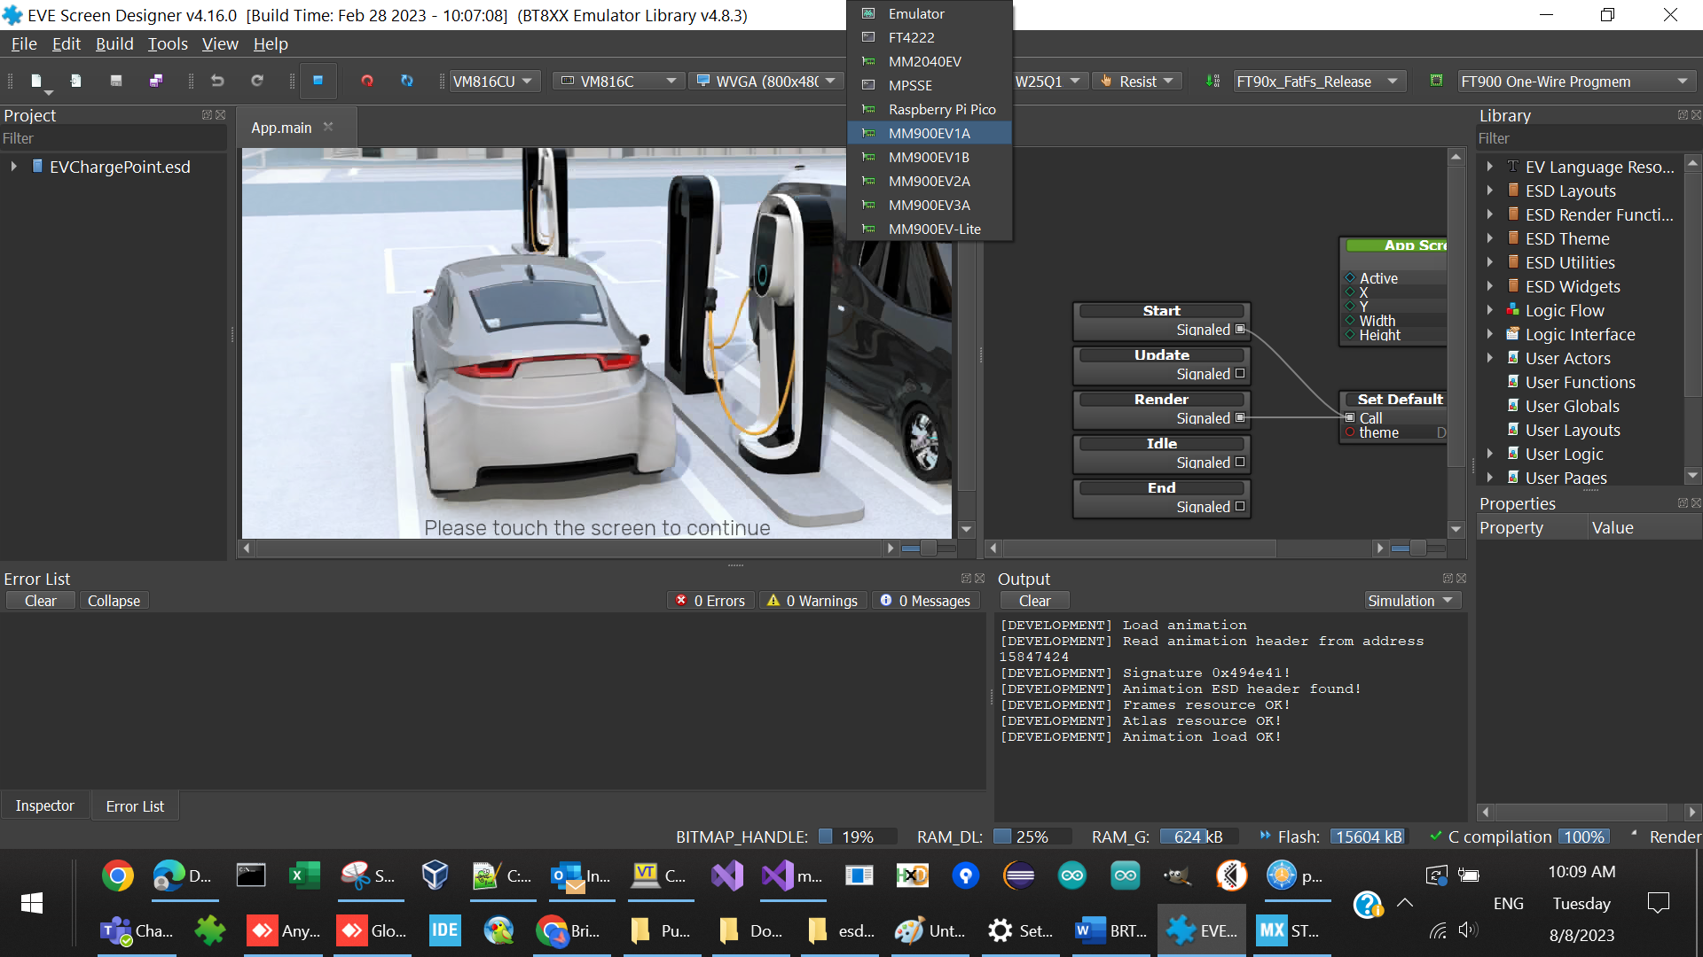

Figure : Select host platform as FT9xx

# Porting principles

## Hardware

An ESD 4.16exported project usually needs access to the following hardware resources of the MCU:

* SPI interface: Read/Write the EVE module
* Clock: Provide delay and timing control functionality
* Storage media: To store bitmap assets, usually it is flash, SD/MMC card, USB disk etc.

Different MCU’s have different hardware configurations. Therefore, users need to ensure that the hardware components above work well. Users are assumed to be familiar with BT81x series ICs as well as EVE3 series modules before starting the porting work. Refer to [brtchip.com](http://brtchip.com/eve-2-development-modules-landing/) for more details.

## Software

Apart from hardware, users are required to modify or add the following software modules:

* **Additional EVE_Hal implementation for the target host platform:** Initialize the targeting MCU platform and re-implement the transportation layer API for the EVE chip interface. This must be modified manually by comparing the reference project.
* **Project files:** Configuration and instructions for building the project. MCU tool chain specific.
* **Linker script:** Instruct the linker software to generate an MCU platform specific binary.

# Example

This example illustrates how to accomplish the porting activity, concurring to the above stated principles.

The selected target MCU platform is an [STM32L476 Discovery board](http://www.st.com/en/evaluation-tools/32l476gdiscovery.html). It shall be connected to the development PC via a USB cable for downloading, debugging and power supply.

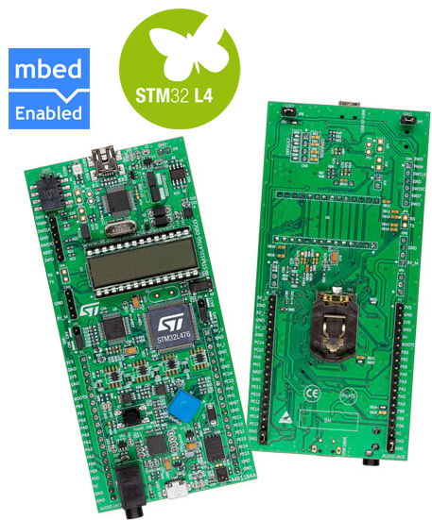

Figure STM32L4 Discovery Board

Selected EVE**Error! Reference source not found.** module VM816C (included BT816 and LCD 800x480):

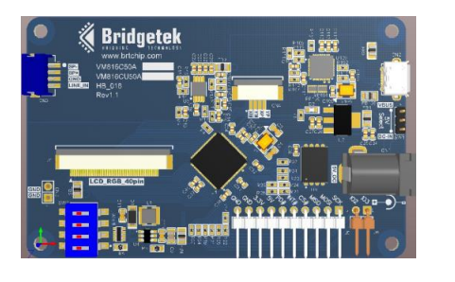

Figure VM816C Module

Here is the connection between two boards:

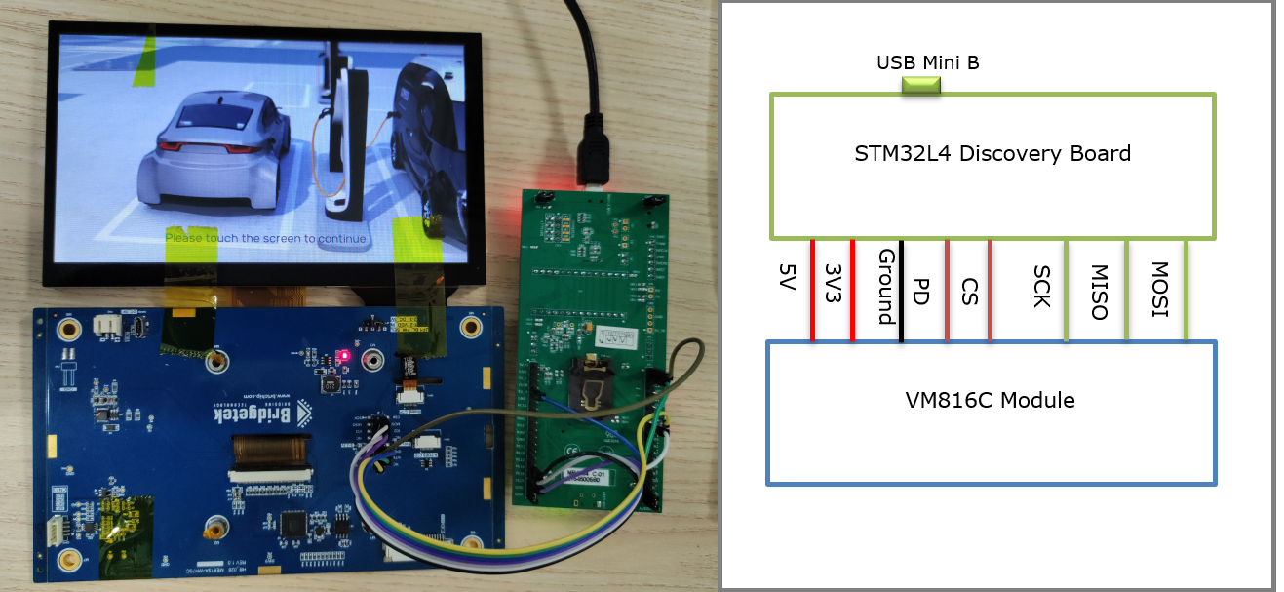

Figure Hardware Setup

The “EvChargePoint” example project from the ESD 4.16examples folder is used to demonstrate how the porting will be done. The “EvChargePoint” example is located at *“$(ESD*4.16*Installation Folder)\\Examples\\Advanced”* folder. Here is a sample screenshot after it is opened in ESD 4.16:

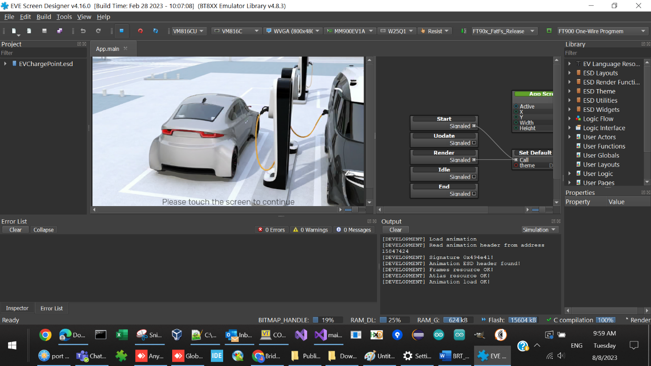**Figure 8 ESD 4.16 EvChargePoint Project Screenshot**

## Hardware Connection

### Power and Ground Connection

VM816C module is powered by both pin 5V and 3.3V, supply from the STM32L4 Discovery board and a ground pin is also connected.

The 3.3v power must be provided for the touch functionality of the VM816C.

### Signal lines Connection

In this example, STM32L4’s SPI 1 interface is selected, and the following connection is set up:

|  |  |  |
| --- | --- | --- |
| MCU Pin Name | MCU Function | EVE Pin name |
| PB2 | GPIO | #PD |
| PE8 | GPIO | #CS |
| PE13 | SPI1_SCK | SCK |
| PE14 | SPI1_MISO | MISO |
| PE15 | SPI1_MOSI | MOSI |
| 5V | 5V | Main power |
| 3.3V | 3.3V | Touch power |
| GND | GND | Ground |

Table MCU and EVE Connection

Care must be taken if connecting the two boards with simple jumper wires. It may be necessary to lower the frequency of the SPI clock by setting the BR bits of the SPIx_CR1 register to ensure a stable signal quality.

## Software Setup

### Toolchain and Utility

For this example porting exercise, the [STM32CubeIDE](https://www.st.com/en/development-tools/stm32cubeide.html) is selected as the compiler and linker for the STM32L4, it is a free software.

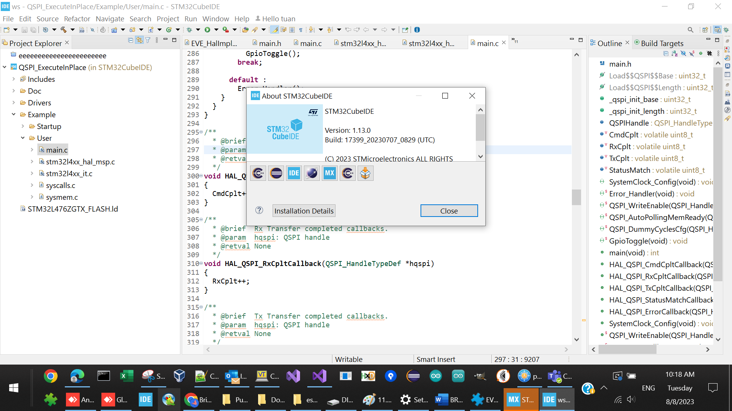

Figure STM32CubeIDE Tool - About Window

Another very helpful tool is called “STM32CubeMX”, which is downloadable from [here](http://www.st.com/en/development-tools/stm32cubemx.html). This tool can help users configure pin functionality easily. In addition, it automatically generates the source code to configure hardware resource.

The following file is the project file of the STMCubeMX tool which is used by the example project specified in this document.

The following screenshot shows how the pin configuration looks like once the project is opened using the STMCubeMX tool. User can open file STM32L476G_With_EVE.ioc with STMCubeMX for more detail.

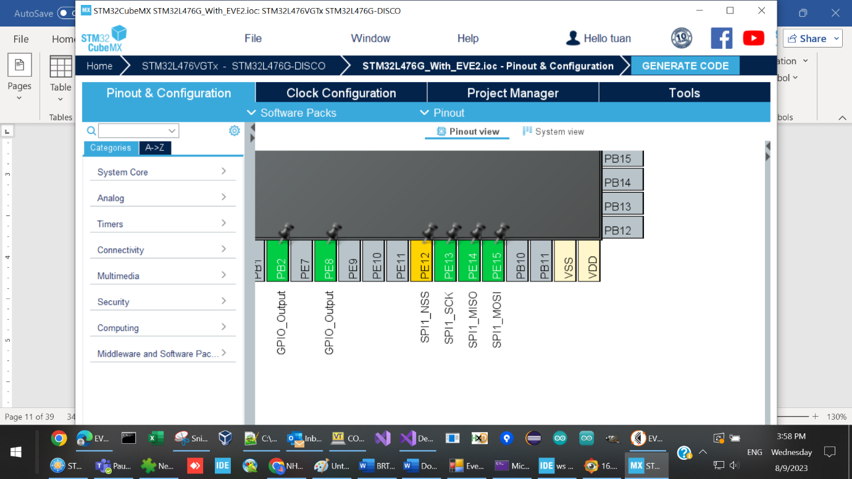.

Figure STMCubeMX Snapshot

## Project porting procedure

This section describes how to use STMCubeMX and STM32CubeIDE to port an ESD project to STM32L4 Discovery board.

Basically, we generate project for STM32L4 Discovery board by STMCubeMX at first, then use this project to build the ESD generated source code on STM32CubeIDE.

**STMCubeMX** generated project

**ESD** generated source code

Build on **STM32CubeIDE**

Binary for STM32L4 Discovery

Figure Project porting procedure

### Create project on ESD and generate source code for eclipse IDE

1. On ESD, open “EvChargePoint” project

It is located at “$(ESD4.16Installation Path)\Examples\Advanced” folder.



Figure The EvChargePoint project on ESD

1. Configure the ESD to use the right Eve platform and LCD size.

In this example, we use VM816C platform, with an LCD 800x480 in size.

1. Export the project to local folder

Select File -> “Export as Eclipse Project” and choose a local folder to store export files.

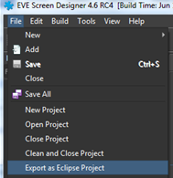

Figure Export as Eclipse Project

The exported project has below files and folders:



Figure ESD exported project files and folders

Remove 2 project file from the generated project file:

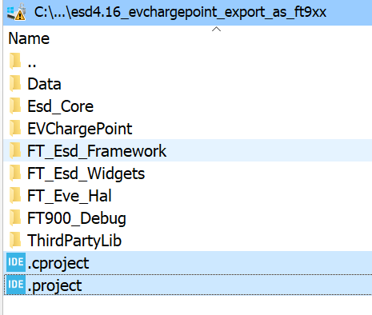

### Generate project for STM32L4 Discovery board

1. Open STMCubeMX and select “ASSESS TO BOARD SELECTOR”

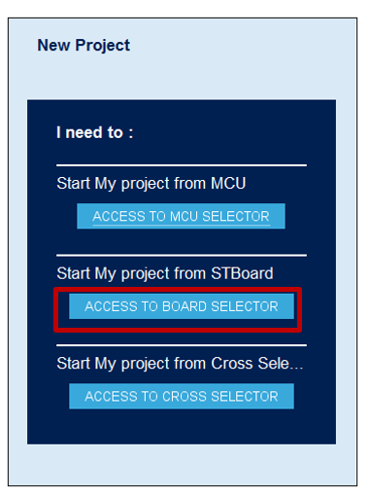

Figure ASSESS TO BOARD SELECTOR

1. Select 32L476GDISCOVERY board

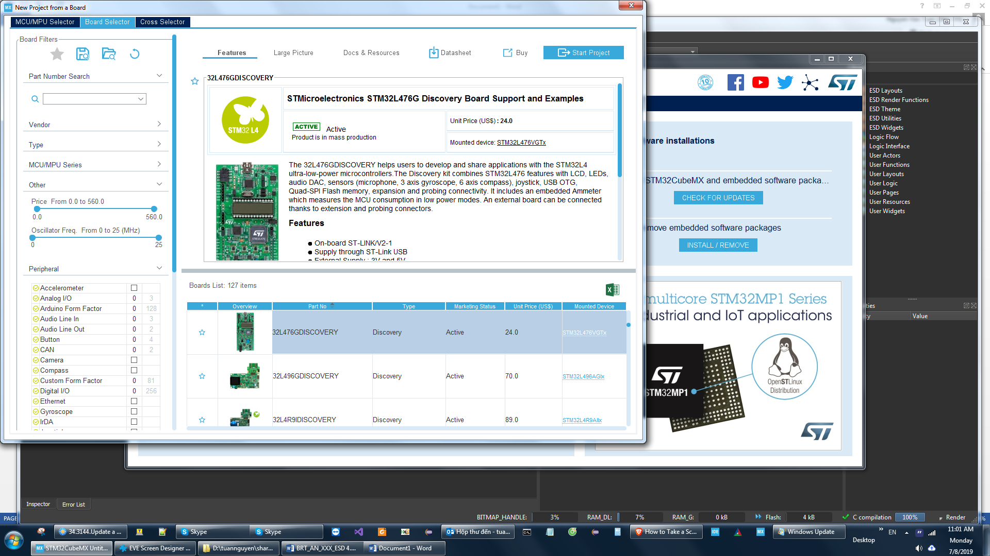

Figure Select 32L476GDISCOVERY board

1. Select default setting for all peripherals

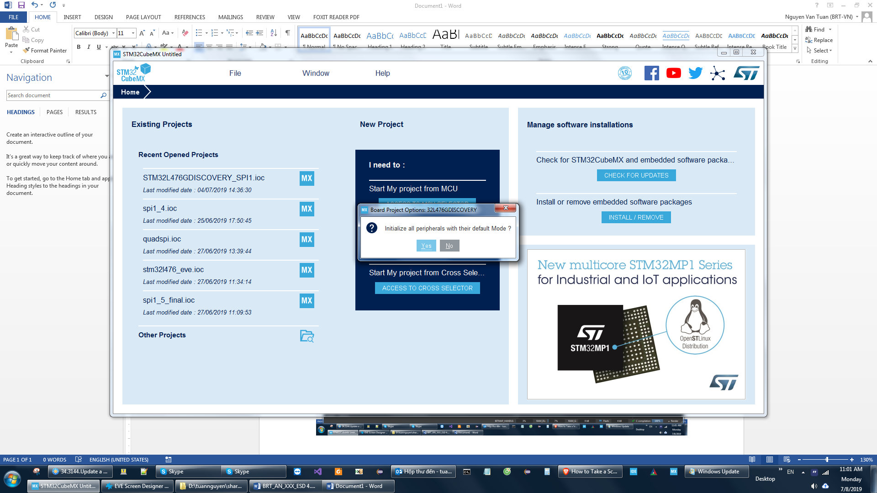

Figure select default mode

1. The Pinout and configuration screen appear

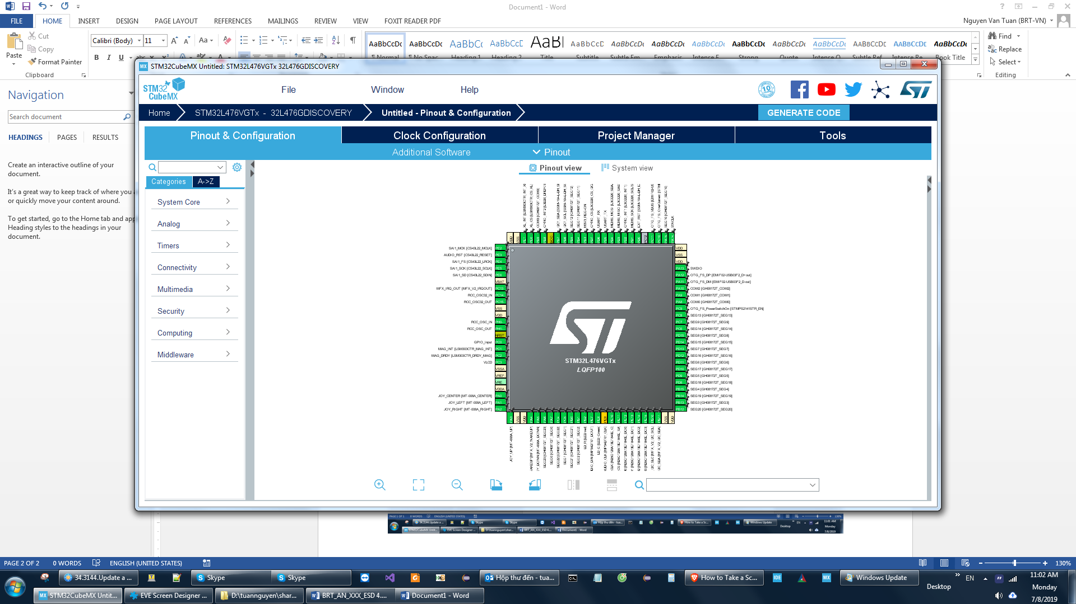

Figure Pinout and configuration screen

1. Setting PINs for SPI1 on the STM32L4 board

Click on the PE12 pin and select SPI1_NSS.

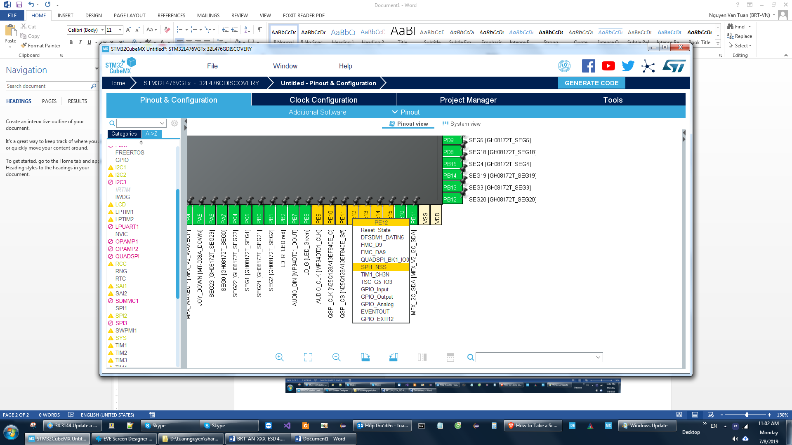

Figure Select SPI1_NSS on PE12

Select SPI1_SCK, SPI1_MISO and SPI1_MOSI for PE13, PE14, PE15. Set PE8 and PB2 as GPIO_Output

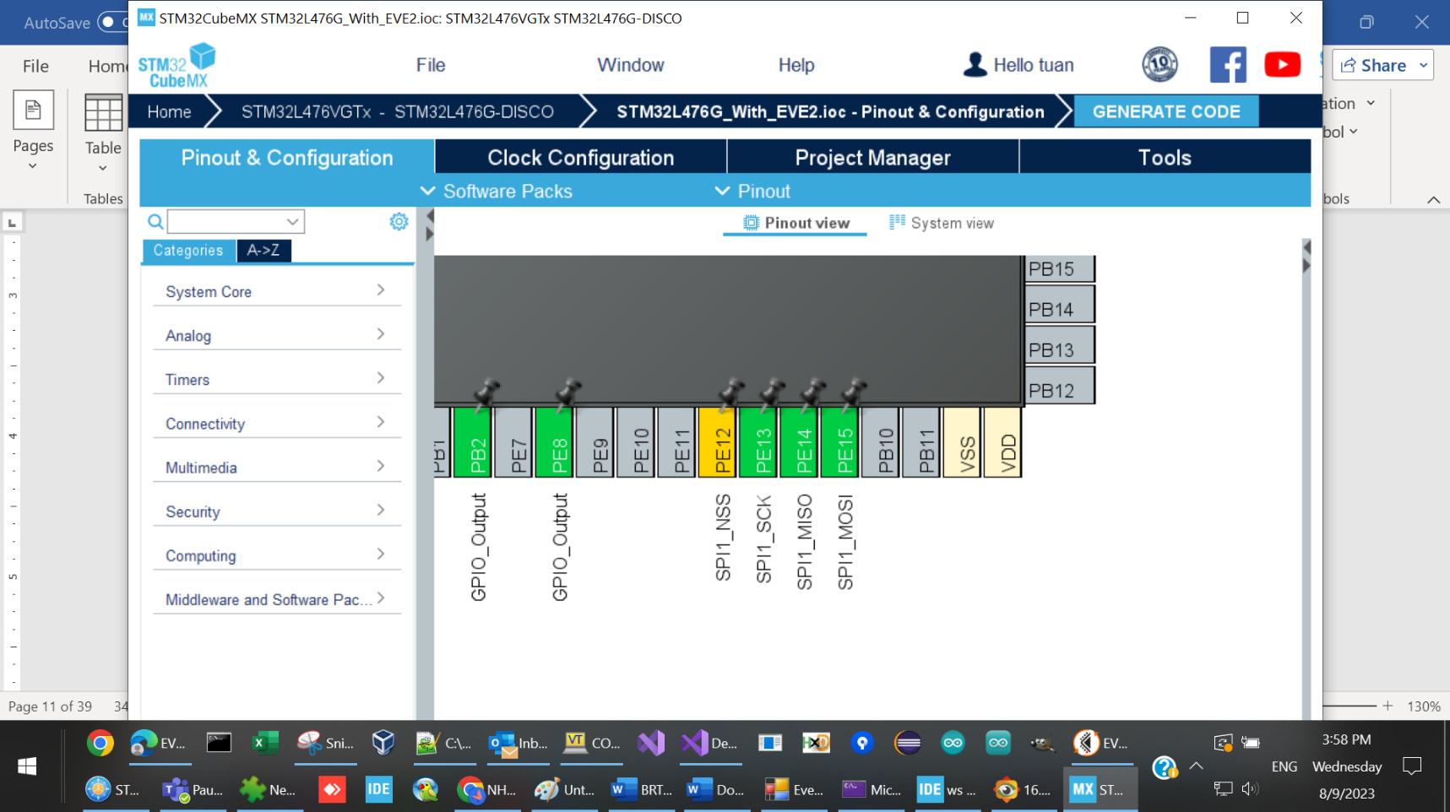

Figure Select SPI1_SCK, SPI1_MISO and SPI1_MOSI

1. Enable SPI1

Set SPI1 to “Full-Duplex master” mode

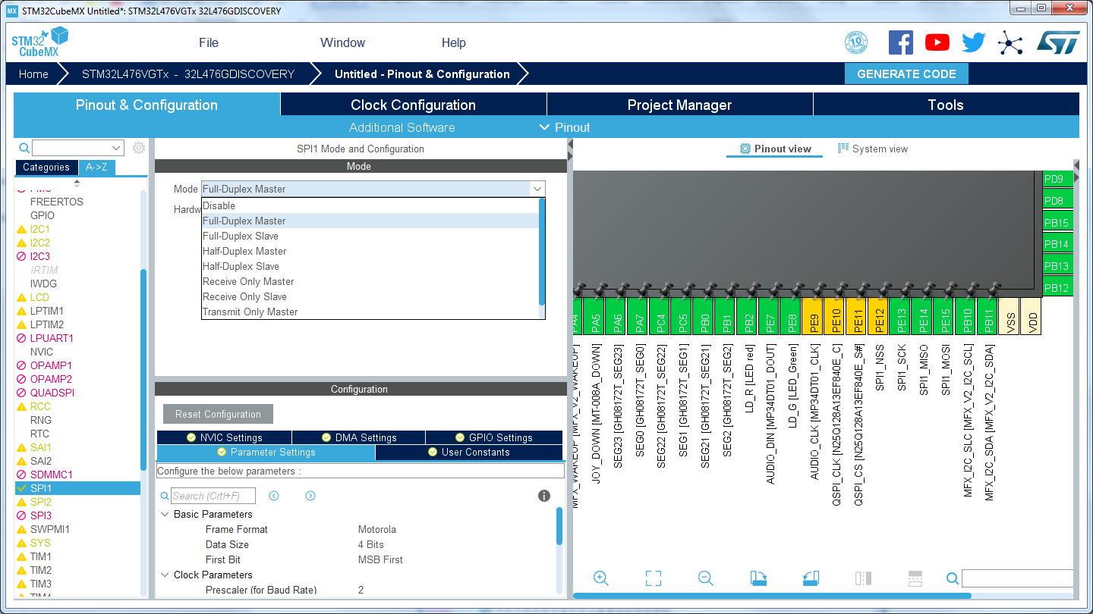

Figure Set SPI1 to Full-Duplex master

Set Data size = 8 for SPI1

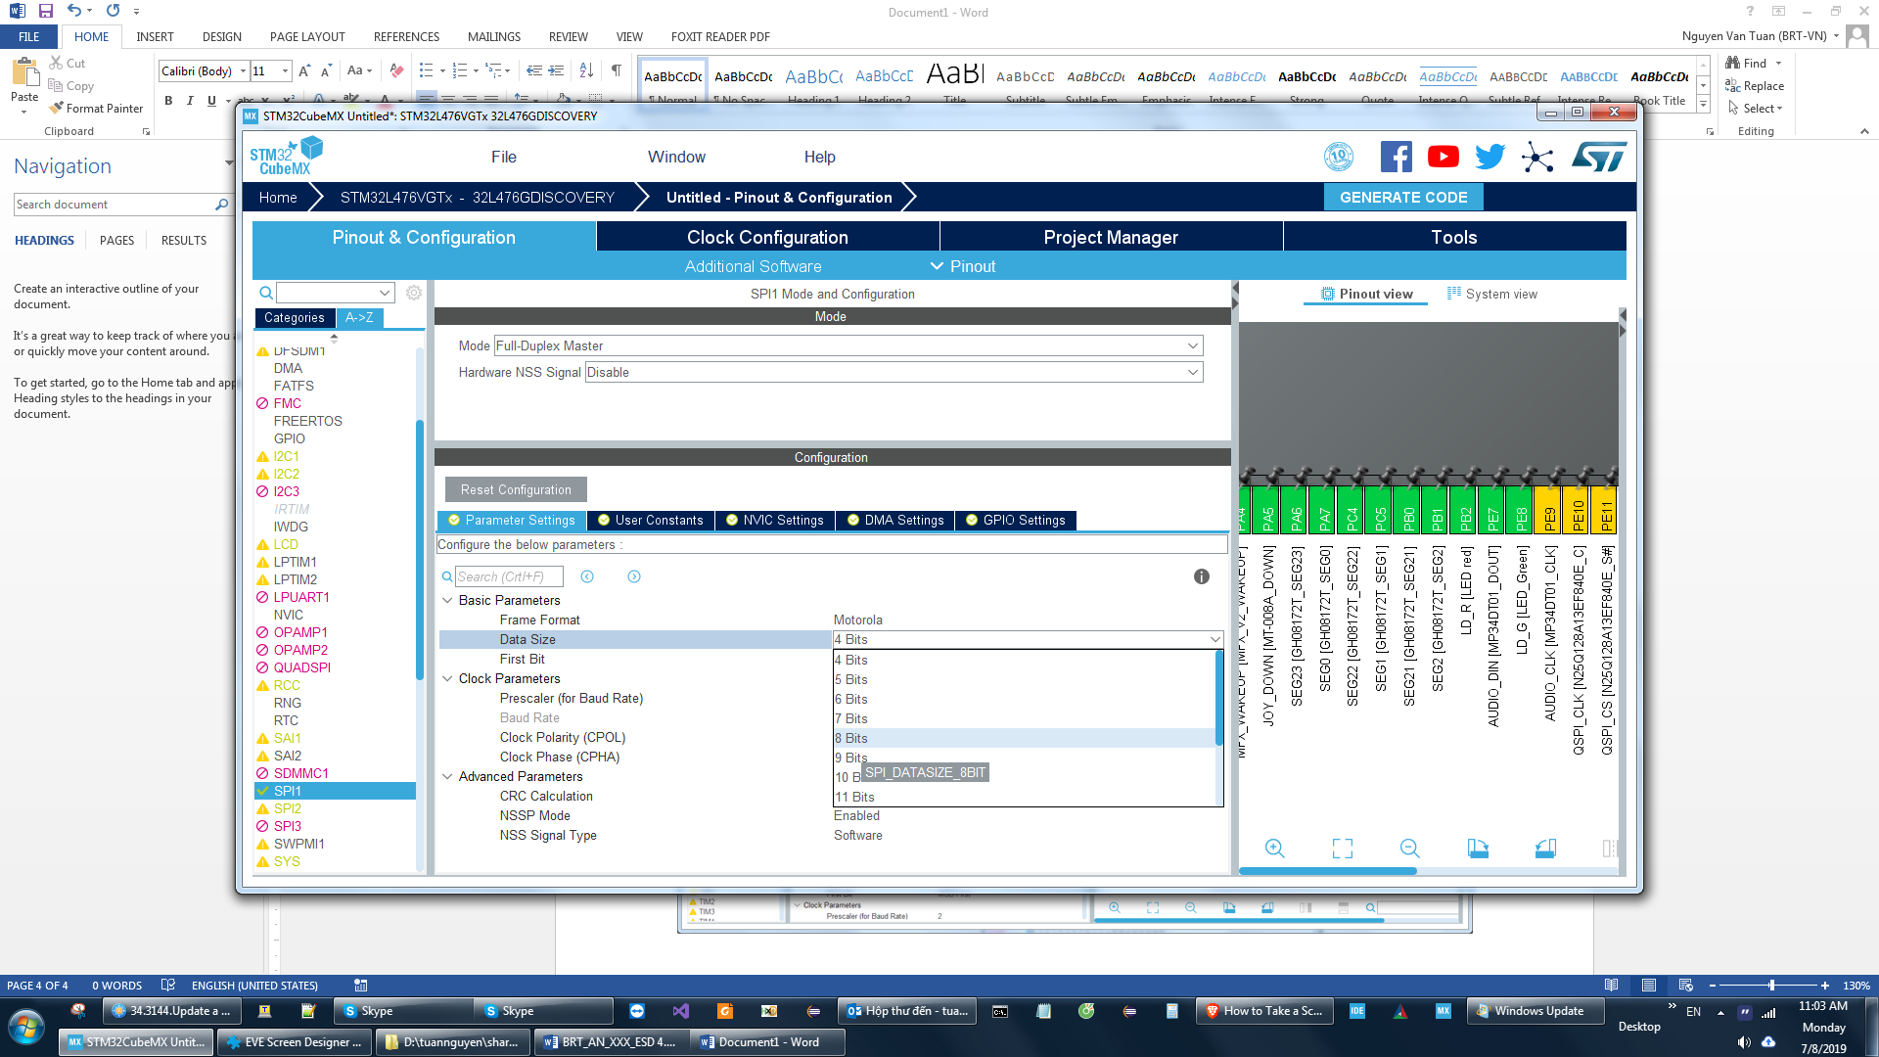

Figure SPI1 - Data size

1. Export project for 32L476GDISCOVERY board

* Select tab “Project manager”
* Input the project name, such as “STM32L476G_With_EVE”
* Input the project path
* Select “toolchain/IDE” is “STM32CubeIDE”.

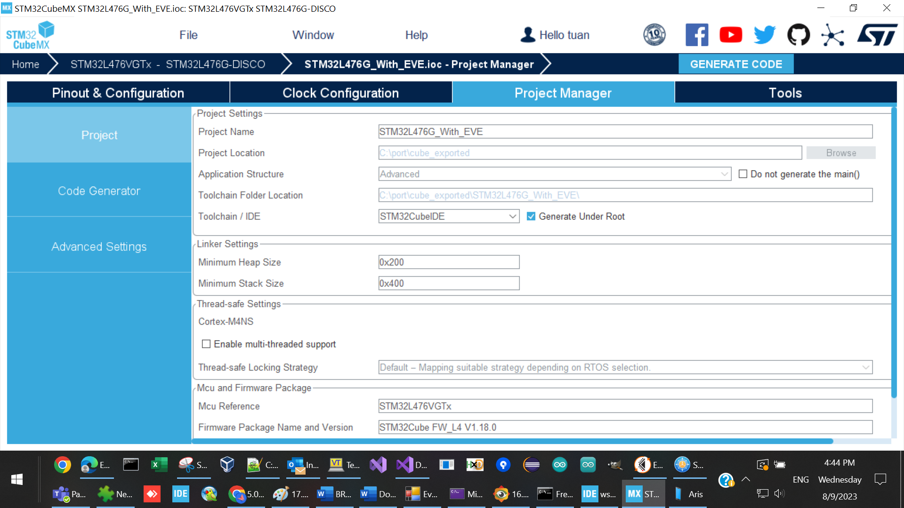

Figure Export project for 32L476GDISCOVERY board

Click button “GENERATE CODE”, wait for STMCubeMX complete this action



Figure Generate code in progress

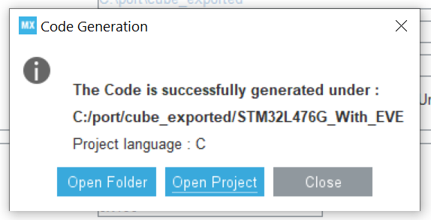

Figure 25 Generate code done

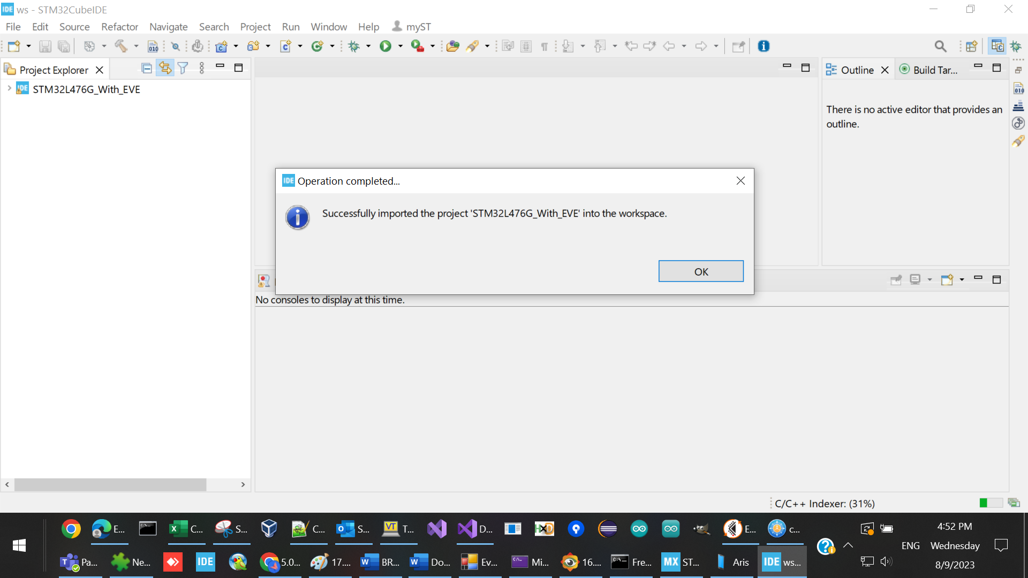

Figure 26 Import code

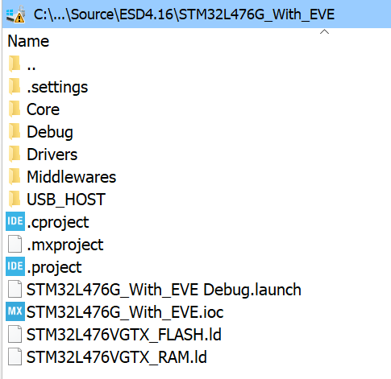

Figure the generated project files for 32L476GDISCOVERY board

### Port ESD generated source code to STM32L4 Discovery’s project

#### Load generated STM32L4 Discovery’s project to STM32CubeIDE

1. Copy ESD generated files to the generated STM32L4 Discovery’s project

Create subfolder “EVE_project” in the generated STM32L4 Discovery’s project

Copy the whole folder “esd4.16_evchargepoint_export_as_ft9xx” into “EVE_project”

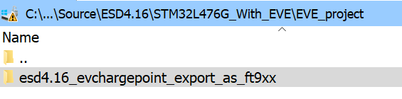

Figure 28 Copy ESD generated source code into STM32 Cube MX generated folder

1. Create subfolder “EVE_porting” in the generated STM32L4 Discovery’s project

In this folder, add your implementation of the STM32 host platform.

Please refer to the github for an example implementation.

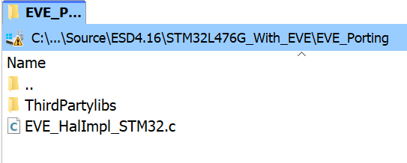

Figure A simple implementation of the STM32 host platform

#### Build configuration on STM32CubeIDE

1. Add include path to ESD generated header files

Right click on project name, select Properties->C/C++ General -> path and Symbols -> “includes” tab

Click “Add” button to add below include path:

* EVE_project/esd4.16_evchargepoint_export_as_ft9xx/Esd_Core
* EVE_project/esd4.16_evchargepoint_export_as_ft9xx/EVChargePoint
* EVE_project/esd4.16_evchargepoint_export_as_ft9xx/FT_Esd_Framework
* EVE_project/esd4.16_evchargepoint_export_as_ft9xx/FT_Esd_Widgets
* EVE_project/esd4.16_evchargepoint_export_as_ft9xx/FT_Eve_Hal
* EVE_project/esd4.16_evchargepoint_export_as_ft9xx/ThirdPartyLib/fatfs
* EVE_project/esd4.16_evchargepoint_export_as_ft9xx/ThirdPartyLib/littlefs
* EVE_Porting

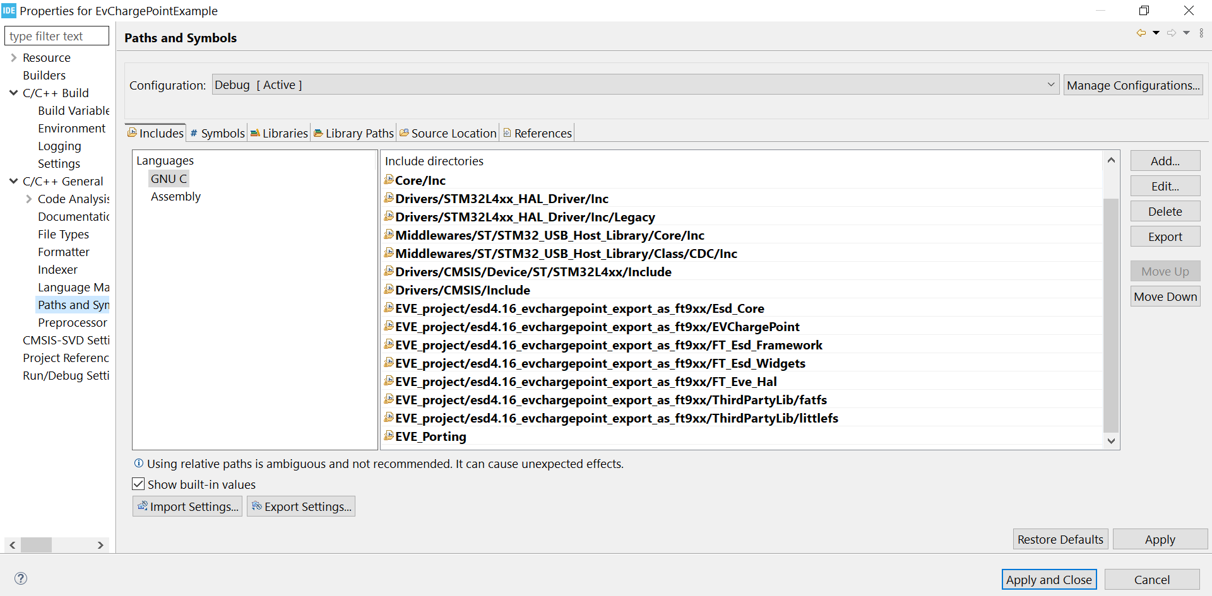

Figure Add include path to ESD generated header files

1. Add platform macro for EVE platform and STM32L4 platform

Select tab “Symbols” and add below definitions:

* EVE_GRAPHICS_AVAILABLE
* BT816_ENABLE
* EVE_USE_INTERNAL_OSC
* EVE_TOUCH_RESISTIVE
* EVE_DISPLAY_WVGA
* EVE_HOST=99
* EVE_FLASH_W25Q16=1

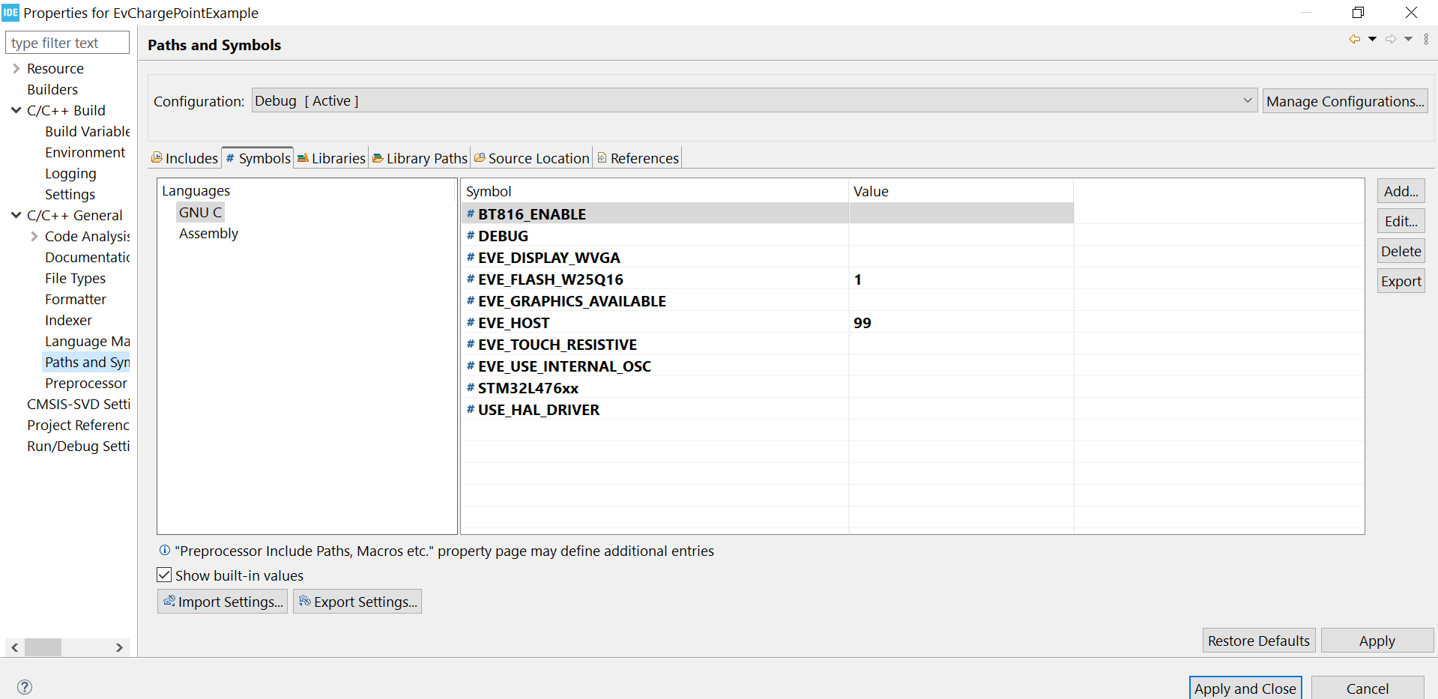

Figure Add platform macro

#### Source code modification

1. Open App__Generated.c file, rename “main” function to “ESD_Start”

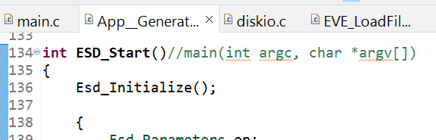

Figure Modify App__Generated.c

1. Open main.c file, call to “ESD_Start” in the while loop

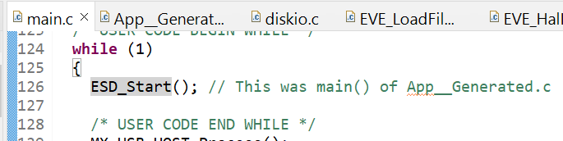

Figure 33 Modify main.c

1. Exclude some source files from the compilation

Right click on below files/folder, select “Resource configuration” -> “Exclude from build”:

* esd4.16_evchargepoint_export_as_ft9xx/FT_Eve_Hal/EVE_LoadFile_STDIO.c
* esd4.16_evchargepoint_export_as_ft9xx/FT_Eve_Hal/EVE_LoadFile_FATFS.c
* esd4.16_evchargepoint_export_as_ft9xx/ThirdPartyLib

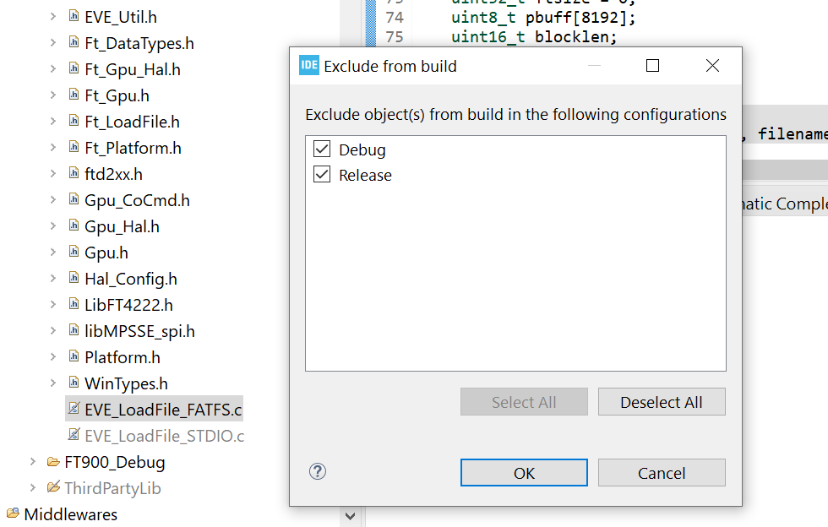

Figure Exclude from the compilation

### Build and run on STM32L4 Discovery board

1. Build project

Press Ctrl + B to compile

1. Run on STM32L4 Discovery board

Select Run->”Run Configuration”

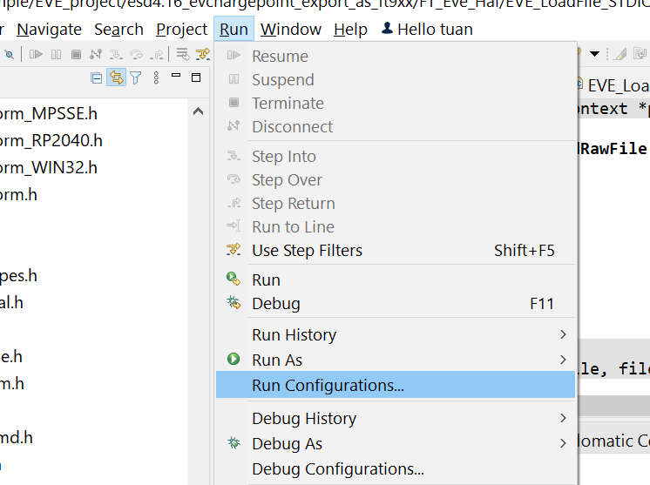

Figure Run Configuration

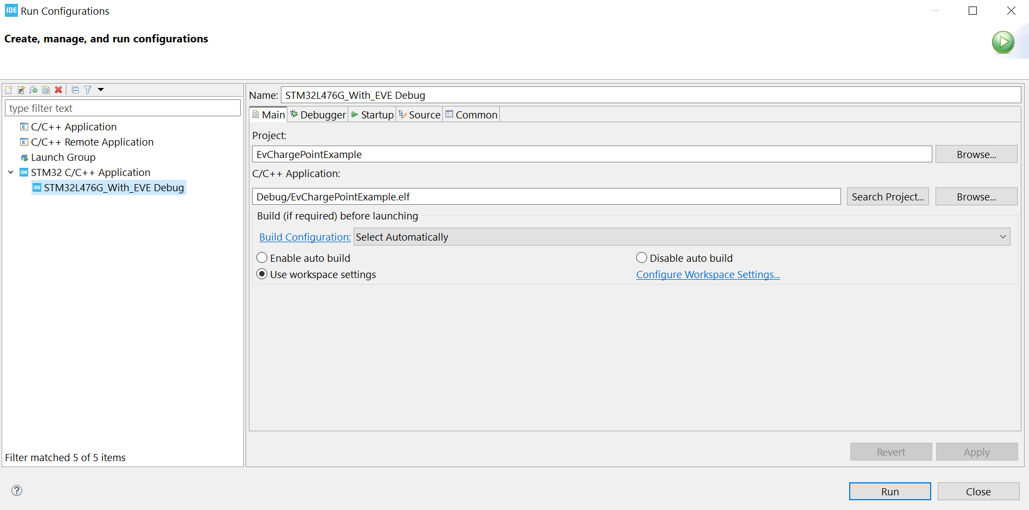

Figure 36 Run Configuration

Add a new run configuration for “STM32 application”, click run button

The application shall be displayed on LCD

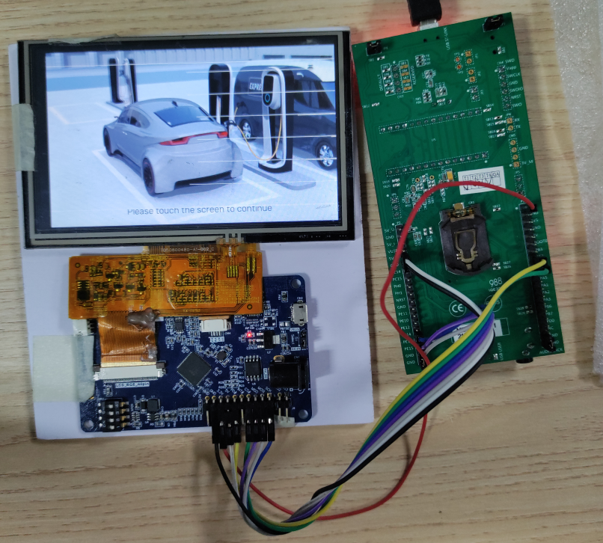

Figure The application

### Storage Media Configuration and Access

In this example, the storage media is not enabled to simplify the procedure.

To access bitmap assets, users need to re-implement the functions below in file “Src\ESD\FT_Eve_Hal\EVE_LoadFile_FATFS.c” for STM32L4 platform:

bool EVE_Util_loadImageFile(EVE_HalContext *phost, uint32_t address, const char *filename, uint32_t *format)

bool EVE_Util_loadInflateFile(EVE_HalContext *phost, uint32_t address, const char *filename)

bool EVE_Util_loadRawFile(EVE_HalContext *phost, uint32_t address, const char *filename)

bool EVE_Util_loadSdCard(EVE_HalContext *phost)

User may need have a FATFS library to implement these functions.

| API name | Remarks |
| --- | --- |
| **Ft_Hal_LoadImageFile** | It loads the image file from storage media with specified “filename” to EVE RAM_G “address” and sends the data through coprocessor command “CMD_LOADIMAGE”. |
| **Ft_Hal_LoadInflateFile** | It loads the deflated file from storage media with specified “filename” to EVE RAM_G “address” and sends the data through coprocessor command “CMD_INFLATE”. |
| **Ft_Hal_LoadRawFile** | It loads the raw image file from storage media with specified “filename” to EVE RAM_G “address”. |
| **Ft_Hal_LoadSDCard** | Prepare SD card if it is used in FATFS. Otherwise, just make it as empty. |

In our example, these four functions are kept Empty.

The STM32L476G Discovery doesn't have internal flash memory or SD card reader port, it can communicate with an external SD card reader to read or write files like image below:

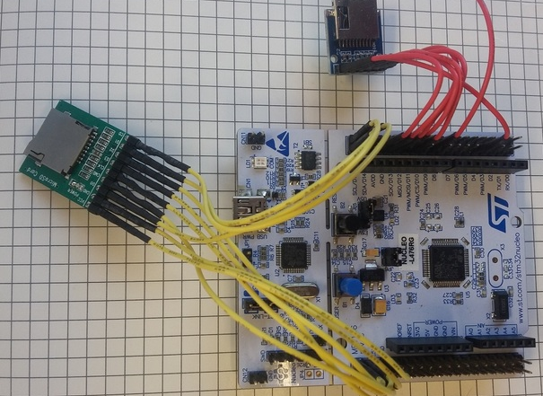

Figure External SD card reader

### APIs Re-Implementation

To make the MCU boot up and communicate with its peripheral, the following APIs are required to be re-implemented. In this example, the implementation is done in EVE_HalImpl_STM32L476GDISCOVERY.c.

| No | API name | Header file | Remarks |
| --- | --- | --- | --- |
|  | EVE_millis | EVE_HalImpl.h | Global counter of up time |
|  | EVE_Millis_initialize | EVE_HalImpl.h | Initialize the global counter |
|  | EVE_Millis_release | EVE_HalImpl.h | De- initialize the global counter |
|  | EVE_sleep | EVE_Hal.h | Sleep in miliseconds |
|  | EVE_Mcu_initialize | EVE_HalImpl.h | Initialize the MCU and its peripheral (SPI, GPIO) |
|  | EVE_Mcu_release | EVE_HalImpl.h | Initialize the MCU and its peripheral (SPI, GPIO) |
|  | EVE_HalImpl_initialize | EVE_HalImpl.h | Initialize system |
|  | EVE_HalImpl_release | EVE_HalImpl.h | De-initialize system |
|  | EVE_HalImpl_defaults | EVE_HalImpl.h | Get the default configuration parameters |
|  | EVE_HalImpl_open | EVE_HalImpl.h | Prepare software structure |
|  | EVE_HalImpl_close | EVE_HalImpl.h | Close software structure handle |
|  | EVE_HalImpl_idle | EVE_HalImpl.h | Idle state of the application, will be called regularly to update frequently changing internal state |
|  | EVE_Hal_startTransfer | EVE_HalImpl.h | Initiate address phase by transmitting 3 bytes address code and assert CS |
|  | EVE_Hal_endTransfer | EVE_HalImpl.h | De-assert the CS to end the SPI transferring |
|  | EVE_Hal_flush | EVE_HalImpl.h | Flush command buffer to EVE |
|  | EVE_Hal_transfer8 | EVE_HalImpl.h | Send or receive one byte |
|  | EVE_Hal_transfer16 | EVE_HalImpl.h | Send or receive two bytes |
|  | EVE_Hal_transfer32 | EVE_HalImpl.h | Send or receive four bytes |
|  | EVE_Hal_transferMem | EVE_Hal.h | Send or receive a buffer |
|  | EVE_Hal_transferProgmem | EVE_Hal.h | Send a PROGMEM  buffer |
|  | EVE_Hal_transferString | EVE_Hal.h | Send a string |
|  | EVE_Hal_hostCommand | EVE_Hal.h | Send host commands to EVE |
|  | EVE_Hal_hostCommandExt3 | EVE_Hal.h | Send 3 bytes host commands to EVE |
|  | EVE_Hal_powerCycle | EVE_Hal.h | Toggle PD pin to wake up EVE |
|  | EVE_Hal_setSPI | EVE_Hal.h | Switch SPI mode (Single, Double, Quad) |

Table APIs to be changed

Contact Information

|  |  |  |  |
| --- | --- | --- | --- |
| **Head Quarters – Singapore** | | **Branch Office – Taipei, Taiwan** | |
|  | |  | |
| Bridgetek Pte Ltd  178 Paya Lebar Road, #07-03  Singapore 409030  Tel: +65 6547 4827  Fax: +65 6841 6071 | | Bridgetek Pte Ltd, Taiwan Branch  2 Floor, No. 516, Sec. 1, Nei Hu Road, Nei Hu District  Taipei 114  Taiwan , R.O.C.  Tel: +886 (2) 8797 5691  Fax: +886 (2) 8751 9737 | |
|  | |  | |
| E-mail (Sales) | [sales.apac@brtchip.com](mailto:sales.apac@brtchip.com) | E-mail (Sales) | [sales.apac@brtchip.com](mailto:sales.apac@brtchip.com) |
| E-mail (Support) | [support.apac@brtchip.com](mailto:support.apac@brtchip.com) | E-mail (Support) | [support.apac@brtchip.com](mailto:support.apac@brtchip.com) |

|  |  |  |  |
| --- | --- | --- | --- |
| **Branch Office - Glasgow, United Kingdom** | | **Branch Office – Vietnam** | |
|  | |  | |
| Bridgetek Pte. Ltd.  Unit 1, 2 Seaward Place, Centurion Business Park  Glasgow G41 1HH  United Kingdom  Tel: +44 (0) 141 429 2777  Fax: +44 (0) 141 429 2758 | | Bridgetek VietNam Company Limited  Lutaco Tower Building, 5th Floor, 173A Nguyen Van Troi, Ward 11, Phu Nhuan District, Ho Chi Minh City, Vietnam  Tel : 08 38453222 Fax : 08 38455222 | |
|  | |  | |
| E-mail (Sales) | [sales.emea@brtichip.com](mailto:sales.emea@brtichip.com) | E-mail (Sales) | [sales.apac@brtchip.com](mailto:sales.apac@brtchip.com) |
| E-mail (Support) | [support.emea@brtchip.com](mailto:support.emea@brtchip.com) | E-mail (Support) | [support.apac@brtchip.com](mailto:support.apac@brtchip.com) |

**Web Site**

<http://brtchip.com/>

**Distributor and Sales Representatives**

Please visit the Sales Network page of the [Bridgetek Web site](http://brtchip.com/contact-us/) for the contact details of our distributor(s) and sales representative(s) in your country.

System and equipment manufacturers and designers are responsible to ensure that their systems, and any Bridgetek Pte Limited (BRTChip) devices incorporated in their systems, meet all applicable safety, regulatory and system-level performance requirements. All application-related information in this document (including application descriptions, suggested Bridgetek devices and other materials) is provided for reference only. While Bridgetek has taken care to assure it is accurate, this information is subject to customer confirmation, and Bridgetek disclaims all liability for system designs and for any applications assistance provided by Bridgetek. Use of Bridgetek devices in life support and/or safety applications is entirely at the user’s risk, and the user agrees to defend, indemnify and hold harmless Bridgetek from any and all damages, claims, suits or expense resulting from such use. This document is subject to change without notice. No freedom to use patents or other intellectual property rights is implied by the publication of this document. Neither the whole nor any part of the information contained in, or the product described in this document, may be adapted or reproduced in any material or electronic form without the prior written consent of the copyright holder. Bridgetek Pte Limited, 178 Paya Lebar Road, #07-03, Singapore 409030. Singapore Registered Company Number: 201542387H.

# Appendix A– References

## Document References

[STM32L4 Reference Manual](http://www.st.com/resource/en/reference_manual/dm00083560.pdf)

[STM32L476xx datasheet](http://www.st.com/resource/en/datasheet/stm32l476je.pdf)

[User Manual of STM32L4 Discovery board](http://www.st.com/resource/en/user_manual/dm00172179.pdf)

[BT81x Programmer Guide](http://brtchip.com/wp-content/uploads/Support/Documentation/Programming_Guides/ICs/EVE/FT81X_Series_Programmer_Guide.pdf)

[BT81x Datasheet](http://brtchip.com/wp-content/uploads/Support/Documentation/Datasheets/ICs/EVE/DS_FT81x.pdf)

## Acronyms and Abbreviations

|  |  |
| --- | --- |
| **Terms** | **Description** |
| EVE | Embedded Video Engine |
| EVE3 Module | BT81X series based display module |
| FT900 | FT900 Microcontroller from FTDI |
| SPI | Serial Peripheral Interface |
| USB | Universal Serial Bus |
| ESD 4.16 | EVE Screen Designer 4.16 |

# Appendix B – List of Tables & Figures

## List of Figures

Figure 1 Hardware list 3

Figure 2 Export EvChargePoint project in ESD 4.16 5

Figure 3: Folder Structure of Error! Reference source not found. Project 5

Figure 4: Select host platform as FT9xx 6

Figure 5 STM32L4 Discovery Board 8

Figure 6 VM816C Module 8

Figure 7 Hardware Setup 9

**Figure 8 ESD 4.16 EvChargePoint Project Screenshot** 9

Figure 9 STM32CubeIDE Tool - About Window 11

Figure 10 STMCubeMX Snapshot 11

Figure 11 Project porting procedure 12

Figure 12 The EvChargePoint project on ESD 12

Figure 13 Export as Eclipse Project 14

Figure 14 ESD exported project files and folders 14

Figure 15 ASSESS TO BOARD SELECTOR 15

Figure 16 Select 32L476GDISCOVERY board 15

Figure 17 select default mode 15

Figure 18 Pinout and configuration screen 16

Figure 19 Select SPI1_NSS on PE12 16

Figure 20 Select SPI1_SCK, SPI1_MISO and SPI1_MOSI 17

Figure 21 Set SPI1 to Full-Duplex master 17

Figure 22 SPI1 - Data size 18

Figure 23 Export project for 32L476GDISCOVERY board 18

Figure 24 Generate code in progress 19

Figure 25 Generate code done 19

Figure 26 Import code 19

Figure 27 the generated project files for 32L476GDISCOVERY board 20

Figure 28 Copy ESD generated source code into STM32 Cube MX generated folder 20

Figure 29 A simple implementation of the STM32 host platform 20

Figure 30 Add include path to ESD generated header files 21

Figure 31 Add platform macro 22

Figure 32 Modify App__Generated.c 23

Figure 33 Modify main.c 23

Figure 34 Exclude from the compilation 23

Figure 35 Run Configuration 24

Figure 36 Run Configuration 24

Figure 37 The application 25

Figure 38 External SD card reader 26

## List of Tables

Table 1: Hardware list 3

Table 2: Software list 3

Table 3: Folder Contents 6

Table 4 MCU and EVE Connection 10

Table 5 APIs to be changed 28

# Appendix C– Revision History

Document Title:

Document Reference No.: BRT_000206

Clearance No.: NA

Product Page: http://brtchip.com/utilities/#ESD4

Document Feedback: [Send Feedback](mailto:docufeedback@brtchip.com?subject=Document%20Feedback:%20BRT_AN_001%20Version%201.0)

|  |  |  |
| --- | --- | --- |
| Revision | Changes | Date |
| 0.1 | First Draft | 2017-09-25 |

# Appendix D – Sample source code

Below is the source code of the application mentioned in (4.3), it can be imported to STM32CubeIDE to be built and ran (see 4.3.3.1, at 2)

Please check STM32L476G_With_EVE.zip

Revision History

Revision history (internal use only, please clearly state all changes here before saving the file)

|  |  |  |  |
| --- | --- | --- | --- |
| Revision | Date  YYYY-MM-DD | Changes | Editor |
| 0.1 | 2019-07-18 | Update to ESD 4.6, use STM32CubeIDE instead of TrueSTUDIO | Tuan Nguyen |
| 1.1 | 2023-08-16 | Update to ESD 4.16 | Tuan Nguyen |